**Project Design Phase-II**

**Data Flow Diagram & User Stories**

|  |  |
| --- | --- |
| Date | 26-05-2025 |
| Team ID | LTVIP2025TMID56105 |
| Project Name | HouseHunt: Finding Your Perfect Rental Home |
| Maximum Marks | 4 Marks |

**📊 Data Flow Diagram (DFD) – HouseHunt**

A Data Flow Diagram (DFD) for HouseHunt illustrates how different users—renters, property owners, and admins—interact with the system and how data moves across its core components. It provides a high-level overview of how information flows between user actions, system processes, and data storage.

**🧩 Key Elements Covered in the DFD:**

* **User Interactions:**
  + Renters can register/login, search properties, send booking inquiries, and manage saved listings.
  + Property owners can register/login, add or update property listings, and respond to inquiries.
  + Admins can log in, verify listings, manage user activity, and promote trusted properties.
* **Core Processes:**
  + **User Authentication:** Login and role-based access
  + **Property Search & Filter:** Querying listings based on user filters
  + **Booking & Inquiry System:** Sending and managing inquiry requests
  + **Listing Management:** CRUD operations on rental properties by owners
  + **Admin Controls:** Approving listings, managing user roles, and promoting listings
* **Data Stores:**
  + **Users Collection:** Stores renter, owner, and admin accounts
  + **Properties Collection:** Stores all property listings with details
  + **Bookings Collection:** Stores inquiries, messages, and booking status

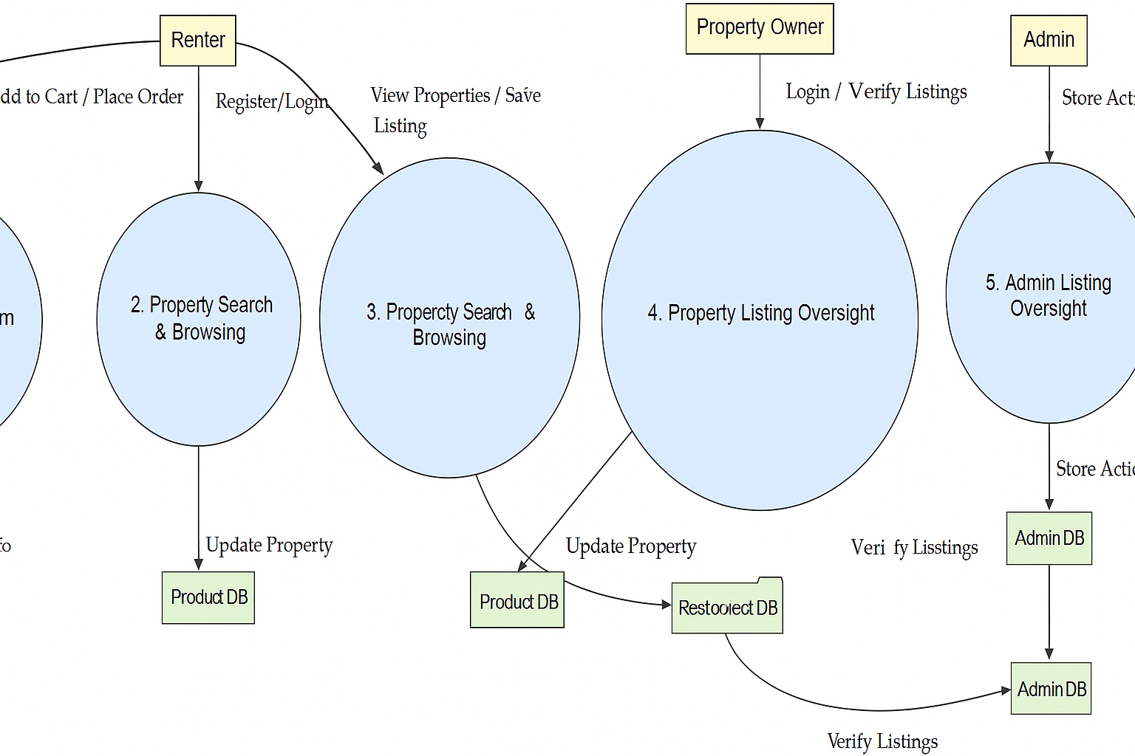

**User Stories**

**User Story Table – Freelance Finder**

|  |  |  |  |  |  |
| --- | --- | --- | --- | --- | --- |
| **User Type** | **Functional Requirement (Epic)** | **User Story / Task** | **Acceptance Criteria** | **Priority** | **Release** |
| **Renter** | User Authentication | As a renter, I can sign up and log in securely. | Account created and token issued on login. | High | Sprint-1 |
| **Renter** | Property Browsing | As a renter, I can view categories and browse rental listings. | Properties shown with categories on homepage. | High | Sprint-1 |
| **Renter** | Listing Viewing & Favorites | As a renter, I can view details and save listings to favorites. | Saved listings reflected in renter’s dashboard. | High | Sprint-2 |
| **Renter** | Booking Inquiry | As a renter, I can send inquiries to property owners. | Inquiry saved and visible to both renter and owner. | High | Sprint-2 |
| **Renter** | Inquiry Tracking | As a renter, I can track responses to my inquiries. | Replies from owners shown in dashboard. | Medium | Sprint-2 |
| **Property Owner** | Dashboard Login | As an owner, I can log in and access my dashboard. | Redirected to dashboard with property list. | High | Sprint-3 |
| **Property Owner** | Property Management | As an owner, I can add/edit/delete rental properties. | Property data updates in database and reflects in listings. | High | Sprint-3 |
| **Property Owner** | Inquiry Management | As an owner, I can view and respond to rental inquiries. | Responses sent and shown in renter dashboard. | Medium | Sprint-3 |
| **Admin** | Admin Login | As an admin, I can log in and view all platform activity. | Admin dashboard loads with user and listing statistics. | High | Sprint-4 |
| **Admin** | Promote Listing | As an admin, I can promote listings to appear on the homepage. | Promoted listings are shown in "Featured" section on frontend. | Medium | Sprint-4 |